1. INTRODUCTION
1.1 Project Overview
This project focuses on analyzing housing market trends using Tableau for visualization and Flask for web integration. The housing dataset contains details such as sale price, renovation year, number of bedrooms, bathrooms, floors, basement area, and house age.
The objective of this project is to transform raw housing data into interactive visual insights through dashboards and storyboards. The final dashboard and story are embedded into a web application using Flask.

1.2 Purpose
- To analyze housing sale price trends
- To study renovation impact on sales
- To understand house age distribution
- To create interactive dashboard and story
- To integrate Tableau dashboard with Flask UI

2. IDEATION PHASE
2.1 Problem Statement
Understanding housing market data is difficult when presented in raw tabular format. Buyers, sellers, and investors require clear visual insights to analyze:
- Sale price trends
- Renovation impact
- House age distribution
- Effect of bedrooms, bathrooms, and floors
Therefore, a visualization-based solution is required.
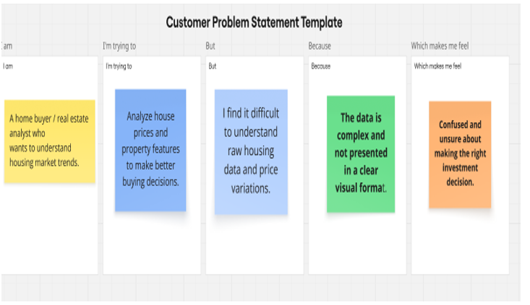

2.2 Empathy Map Canvas
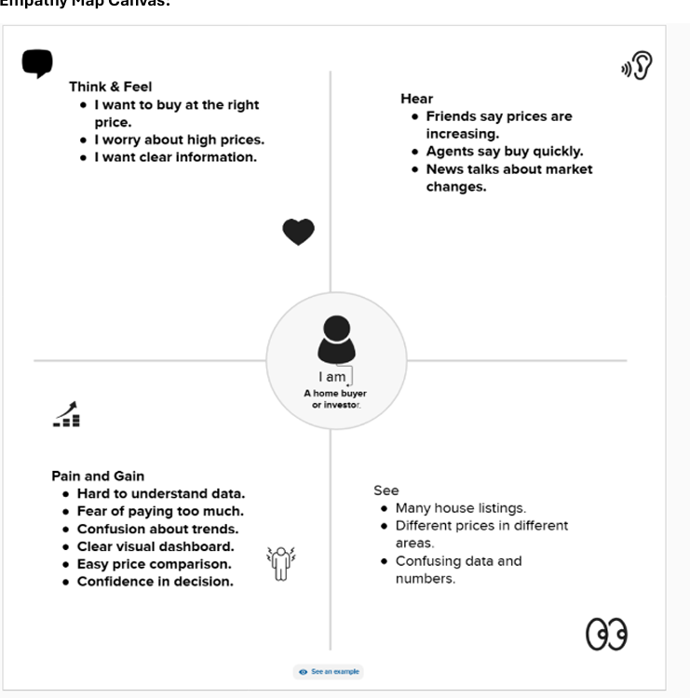

2.3 Brainstorming
Ideas discussed:
- Create sales overview visualization
- Show average sale price
- Show renovation impact
- Analyze house age
- Build interactive dashboard
- Integrate with Flask
Final Idea:
👉 Tableau Dashboard + Story + Flask Integration

3. REQUIREMENT ANALYSIS
3.1 Customer Journey Map
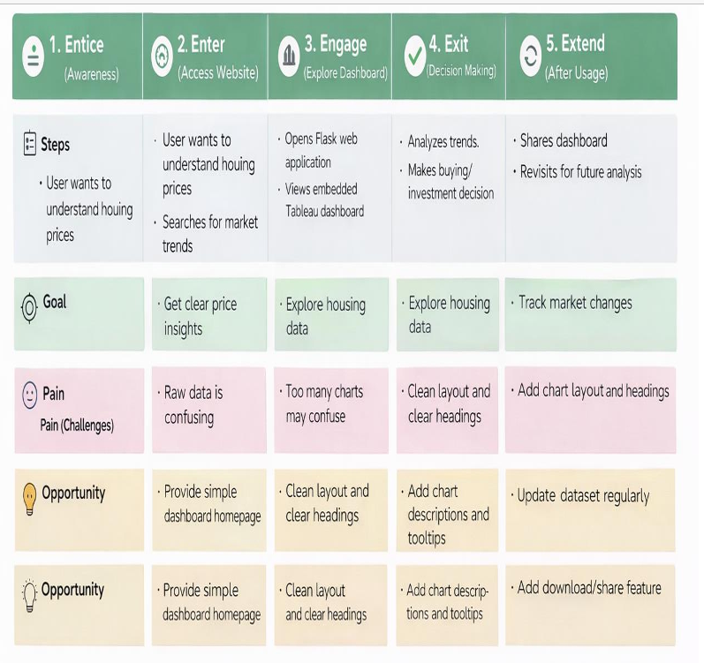

3.2 Solution Requirement
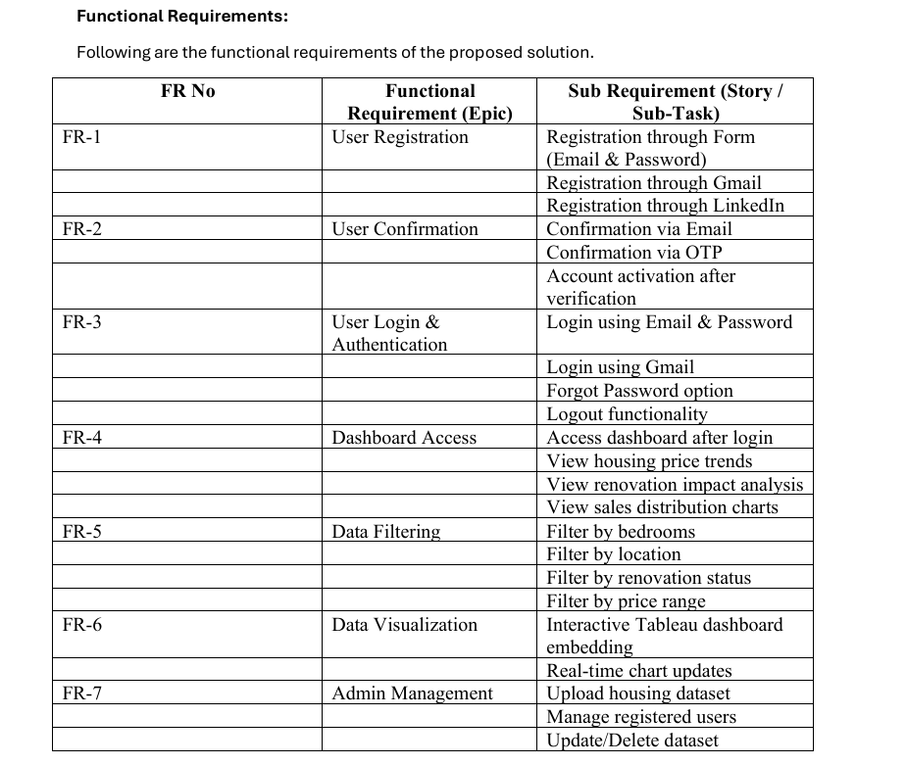
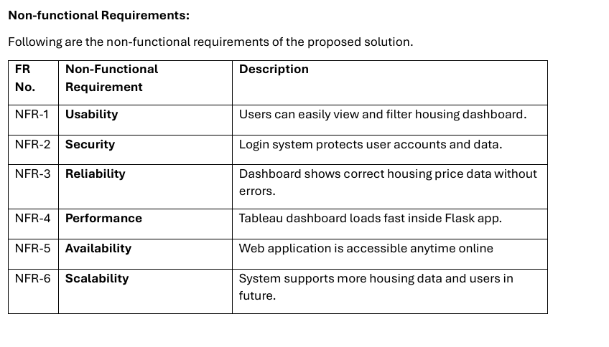

3.3 Data Flow Diagram
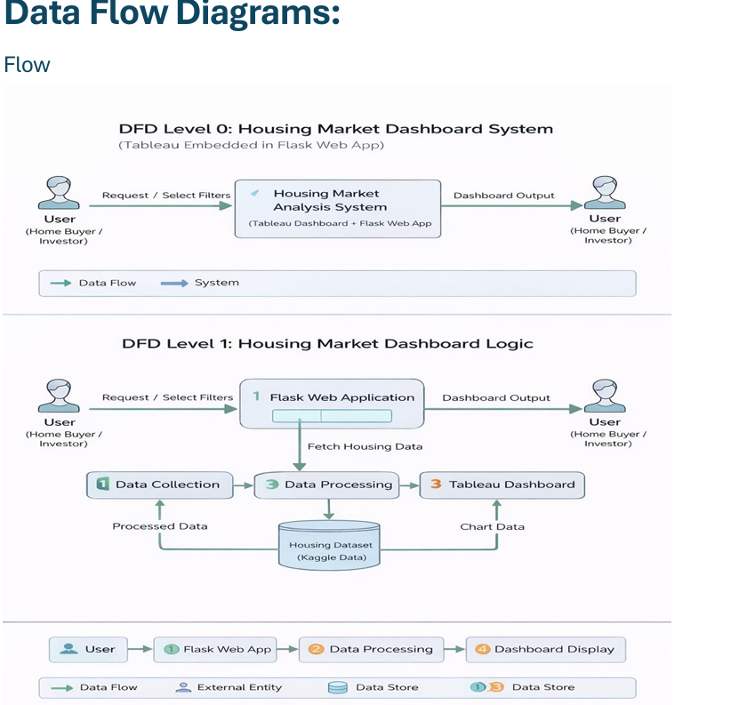

3.4 Technology Stack
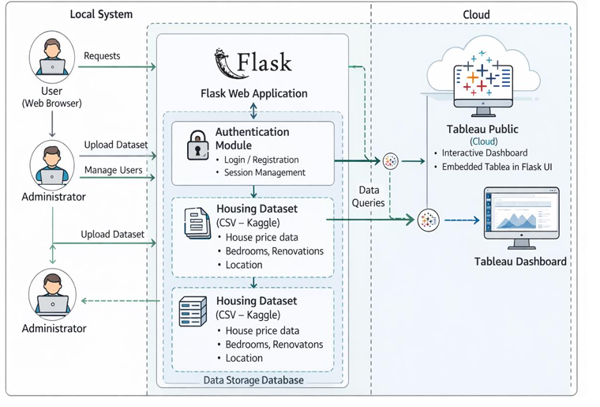
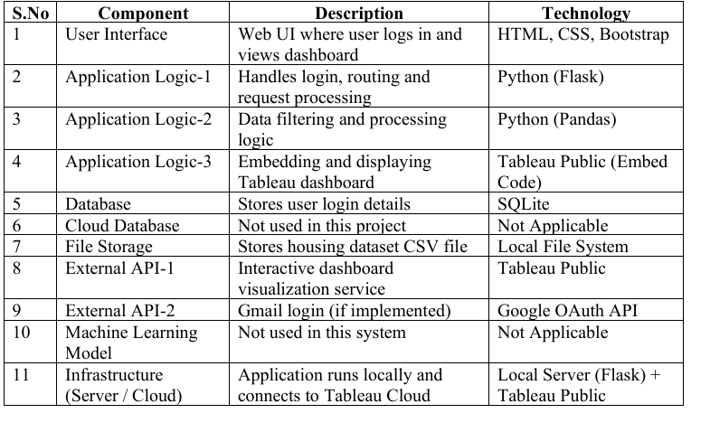
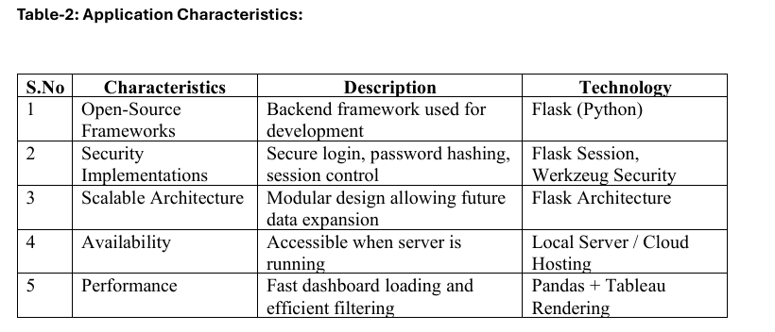
4. PROJECT DESIGN
4.1 Problem Solution Fit
Problem:
Raw housing data is difficult to interpret.
Solution:
Interactive Tableau dashboard and story embedded in Flask.

4.2 Proposed Solution
The system:
- Downloads housing dataset
- Cleans and prepares data
- Creates 6 unique visualizations
- Builds dashboard
- Creates storyboard
- Publishes to Tableau Public
- Embeds dashboard in Flask UI

4.3 Solution Architecture
User
↓
Flask Web Application
↓
Embedded Tableau Dashboard
↓
Tableau Public Server

5. PROJECT PLANNING & SCHEDULING
5.1 Project Planning
Phase | Activity
Phase 1 | Data Collection
Phase 2 | Data Preparation
Phase 3 | Data Visualization
Phase 4 | Dashboard Creation
Phase 5 | Story Creation
Phase 6 | Performance Testing
Phase 7 | Web Integration
Phase 8 | Documentation

6. FUNCTIONAL AND PERFORMANCE TESTING
6.1 Performance Testing
Amount of Data Loaded
- Housing dataset loaded successfully
Utilization of Filters
- Sale Price – Top N Filter
- Age of House – Top N Filter
Number of Calculation Fields
- House Age (Calculated Field)
Number of Visualizations
- Count of Transformed Housing Data
- Total Sales by Years Since Renovation
- Distribution of House Age by Renovation Status
- House Age Distribution by Bathrooms, Bedrooms, and Floors
Total Unique Visualizations: 4

7. RESULTS
7.1 Output Screenshots
(Insert the following screenshots)
- Visualization Sheets

- Dashboard
- Story
- Filters
- Flask Web UI

8. ADVANTAGES & DISADVANTAGES
Advantages
- Easy understanding of housing trends
- Interactive filters
- Web-based accessibility
- Clear data insights
Disadvantages
- Depends on Tableau Public server
- Requires internet connection

9. CONCLUSION
The project successfully visualizes housing market trends using Tableau and integrates the dashboard with Flask. The system helps users analyze sale price patterns, renovation impact, and house age distribution in an interactive way.

10. FUTURE SCOPE
- Add Machine Learning prediction model
- Real-time data integration
- Cloud deployment
- User authentication system

11. APPENDIX
- Source Code:
- Flask code:
from flask import Flask, render_template

app = Flask(__name__)

@app.route('/')
def home():
return render_template('index.html')

if __name__ == '__main__':
app.run(debug=True)

- Index.htnl [html code]:

<!DOCTYPE html>
<html lang="en">
<head>
<meta charset="UTF-8">
<title>Housing Market Trends</title>
<meta name="viewport" content="width=device-width, initial-scale=1.0">

<link href="https://cdn.jsdelivr.net/npm/bootstrap@5.3.2/dist/css/bootstrap.min.css" rel="stylesheet">

<style>
html { scroll-behavior: smooth; }

body {
font-family: 'Segoe UI', sans-serif;
}

/* Navbar */
.navbar {
background: #0d6efd;
}

.navbar .nav-link,
.navbar-brand {
color: white !important;
font-weight: 500;
}

/* Sections Animation */
section {
min-height: 100vh;
padding: 100px 0;
opacity: 0;
transform: translateY(40px);
transition: 0.8s ease-in-out;
}

section.show {
opacity: 1;
transform: translateY(0);
}

/* Home */
.home {
background: linear-gradient(to right, #4e73df, #1cc88a);
color: white;
text-align: center;
}

/* Buttons */
.btn-custom {
padding: 10px 25px;
border-radius: 30px;
transition: 0.3s;
}

.btn-custom:hover {
transform: scale(1.08);
}

/* Iframe */
iframe {
border-radius: 15px;
box-shadow: 0 8px 20px rgba(0,0,0,0.2);
transition: 0.3s;
}

iframe:hover {
transform: scale(1.02);
}

footer {
background: #0d6efd;
color: white;
text-align: center;
padding: 15px;
}
</style>
</head>

<body>

<!-- NAVBAR -->
<nav class="navbar navbar-expand-lg fixed-top">
<div class="container">
<a class="navbar-brand" href="#home">🏠 Housing Trends</a>
<div>
<a class="nav-link d-inline" href="#home">Home</a>
<a class="nav-link d-inline" href="#dashboard">Dashboard</a>
<a class="nav-link d-inline" href="#story">Story</a>
</div>
</div>
</nav>

<!-- HOME -->
<section id="home" class="home show d-flex align-items-center">
<div class="container">
<h1 class="display-4 fw-bold" id="title"></h1>
<p class="lead mt-3">Interactive Tableau Dashboard & Story using Flask</p>

<a href="#dashboard" class="btn btn-light btn-custom mt-4">
View Dashboard ↓
</a>
</div>
</section>

<!-- DASHBOARD -->
<section id="dashboard" class="bg-light">
<div class="container text-center">
<h2 class="mb-4">📊 Housing Market Dashboard</h2>

<iframe
src="https://public.tableau.com/views/Book1_17696952321770/Dashboard1?:showVizHome=no&:embed=true"
width="100%"
height="700"
frameborder="0"
allowfullscreen>
</iframe>

<br><br>

<a href="#home" class="btn btn-primary btn-custom">Home</a>
<a href="#story" class="btn btn-success btn-custom">Next → Story</a>
</div>
</section>

<!-- STORY -->
<section id="story" class="bg-white">
<div class="container text-center">
<h2 class="mb-4">📖 Housing Market Story</h2>

<iframe
src="https://public.tableau.com/views/Book1_17696952321770/Story1?:showVizHome=no&:embed=true"
width="100%"
height="700"
frameborder="0"
allowfullscreen>
</iframe>

<br><br>

<a href="#home" class="btn btn-dark btn-custom">Back to Home</a>
</div>
</section>

<footer>
© 2026 Internship Project | Tableau + Flask
</footer>

<script>

/* Scroll Animation */
const sections = document.querySelectorAll("section");

window.addEventListener("scroll", () => {
const trigger = window.innerHeight * 0.85;
sections.forEach(sec => {
if(sec.getBoundingClientRect().top < trigger){
sec.classList.add("show");
}
});
});

/* Typewriter Effect */
const text = "Visualizing Housing Market Trends";
let i = 0;
function typing(){
if(i < text.length){
document.getElementById("title").innerHTML += text.charAt(i);
i++;
setTimeout(typing, 50);
}
}
typing();

</script>

</body>
</html>

- Dataset Link:

- Kaggle Housing Dataset:
Visualizing Housing Market Trends An Analysis of Sale Prices and Features using Tableau
https://www.kaggle.com/datasets/rituparnaghosh18/transformed-housing-data-2

GitHub & Project Demo Link:

- GitHub link:
https://github.com/Lakshmi130604/Visualizing-Housing-Market-Trends-An-Analysis-of-Sale-Prices-and-Features-using-Tableau/tree/main

- DEMO VIDEO LINK:

https://drive.google.com/file/d/1df7i8HB70rKN_WyNZiaY7N8xr1_j21z0/view?usp=sharing

- DASHBORDLINK: https://public.tableau.com/views/Book1_17696952321770/Dashboard1?:showVizHome=no&:embed=true

- STORY LINK:
https://public.tableau.com/views/Book1_17696952321770/Story1?:showVizHome=no&:embed=true

  - Project Web Interface LINK:
http://127.0.0.1:5000

